WS2812B Patterns

# Materials

* AmebaD [AMB21 / AMB22 / AMB23 / BW16] x1
* WS2812B LED Strip / Ring / Stick / Board x1

# Example

**Introduction**

In this example, we will be using the AmebaD board to control the WS2812B RGB LED, using the SPI peripheral to create the waveform necessary for the LEDs.

WS2812B_Patterns allows you to create different light patterns with many different colors.

**Procedure**

Firstly, connect the WS2812B to the Ameba board as shown in the following diagrams.

**AMB21/AMB22 Wiring Diagram:**

**AMB23 Wiring Diagram:**

**BW16 Wiring Diagram:**

**BW16-TypeC Wiring Diagram:**

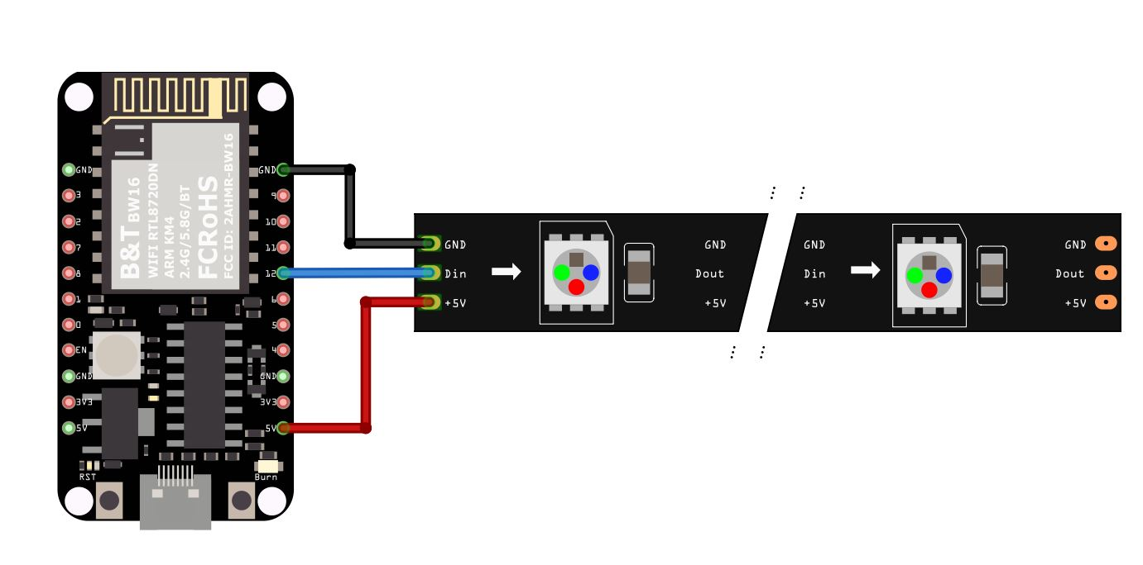

To create different light patterns with many different colors, use **WS2812B_Patterns**.

Open the example in “File” → “Example” → “AmebaWS2812B” → “WS2812B_Patterns”

In the sample code, modify **NUM_OF_LEDS** to be the number of LEDs that you have connected.

Next compile and upload to Ameba, then press the reset button. You will see the WS2812B displaying a color wipe, theater chase, rainbow, and theater chase rainbow light patterns in loop.

# Code Reference

[1] WS2812B Datasheet:

<https://cdn-shop.adafruit.com/datasheets/WS2812B.pdf>